Sample Case Report Manuscript (Prefilled for Workflow Testing)

Authors: A. Author¹, MD; B. Author², MD; C. Author³, PhD
Affiliations: ¹Department of XXX, Institution, Country; ²Department of XXX, Institution, Country; ³Department of XXX, Institution, Country;
Corresponding Author: A. Author, MD (email@example.com)

Article Type: Case Report
Proposed Running Title: Acute Chest Pain With Atypical Imaging Findings
Keywords: case report; diagnostic reasoning; imaging; perioperative care; outcomes

IMPORTANT: This document contains fictional patient information and dummy content intended solely for testing submission, peer review, copyediting, and production workflows.

Section headings, structure, and ordering may be adjusted as appropriate to the specifics of the case and the journal’s editorial requirements.

Abstract
Background: Case reports provide practical, real-world insight into clinical decision-making and diagnostic pathways. We present a fictional case designed to test an end-to-end publishing workflow. Case Presentation: A 54-year-old patient presented with acute chest pain and dyspnea. Initial ECG and troponins were non-diagnostic, but CT angiography suggested an atypical vascular finding requiring multidisciplinary evaluation.
Conclusion: This case highlights the importance of structured assessment, imaging interpretation, and coordinated perioperative planning. All details are fictional and included for workflow testing.

Key Messages
- Structured documentation improves review quality and reduces editorial cycles.
- Imaging interpretation should be linked explicitly to differential diagnosis.
- Consent and anonymization statements must be included even for educational case reports.

Introduction
Acute chest pain is a common presentation with a broad differential diagnosis. This sample manuscript demonstrates a CARE-aligned structure suitable for peer review. The clinical content is fictional and should not be used as medical guidance.

Case Presentation

Patient Information
A 54-year-old patient with a history of hypertension and hyperlipidemia presented to the emergency department with sudden onset chest pain radiating to the back. Medications included amlodipine and atorvastatin. No tobacco or illicit drug use was reported.

Clinical Findings
On arrival, blood pressure was 168/92 mmHg, heart rate 102 bpm, respiratory rate 22/min, SpO2 95% on room air, and temperature 36.8°C. The patient appeared anxious with mild diaphoresis. Cardiac exam revealed tachycardia without murmurs.

Timeline
After formal multidisciplinary evaluation, the clinical team elected to pursue targeted intervention consistent with the suspected diagnosis. A comprehensive perioperative plan was implemented, encompassing airway assessment, hemodynamic optimization, anesthetic considerations, and structured postoperative monitoring.

Table 1. This is Caption for the table
Day/Time | Event | Key Findings / Actions
Day 0, 08:10 | ED presentation | Severe chest pain; vitals recorded; IV access established
Day 0, 08:30 | Initial tests | ECG: non-specific changes; Troponin: negative
Day 0, 09:15 | Imaging | CT angiography: atypical vascular contour; consult requested
Day 0, 11:00 | Multidisciplinary review | Neurosurgery, anesthesia, and radiology discussion
Day 0, 13:30 | Intervention | Procedure performed under general anesthesia
Day 1 | Follow-up | Symptoms improved; discharged with outpatient follow-up plan

Diagnostic Assessment
Laboratory studies are summarized in Table 2. Imaging was performed to evaluate for dissection, pulmonary embolism, and other acute causes. The working differential included aortic pathology, atypical acute coronary syndrome, and esophageal causes.

Table 2. This is Caption for the table
Day/Time | Event | Key Findings / Actions
Day 0, 08:10 | ED presentation | Severe chest pain; vitals recorded; IV access established
Day 0, 08:30 | Initial tests | ECG: non-specific changes; Troponin: negative
Day 0, 09:15 | Imaging | CT angiography: atypical vascular contour; consult requested
Day 0, 11:00 | Multidisciplinary review | Neurosurgery, anesthesia, and radiology discussion
Day 0, 13:30 | Intervention | Procedure performed under general anesthesia
Day 1 | Follow-up | Symptoms improved; discharged with outpatient follow-up plan


Figure 1 This is an example of the image

Therapeutic Intervention
After multidisciplinary discussion, the team proceeded with an intervention appropriate to the suspected diagnosis. Perioperative planning included airway assessment, hemodynamic goals, and postoperative monitoring.

Follow-up and Outcomes
The patient reported significant symptom improvement within 24 hours. No complications occurred during hospitalization. A follow-up visit was scheduled at 2 weeks with repeat imaging as clinically indicated.

Discussion
This fictional case demonstrates how to present a structured narrative suitable for peer review. Key editorial considerations include clarity of timeline, linkage between diagnostics and decisions, and explicit ethical statements. For real submissions, authors should avoid identifiable information and provide consent documentation. Figure 2 provides a simple workflow diagram placeholder.
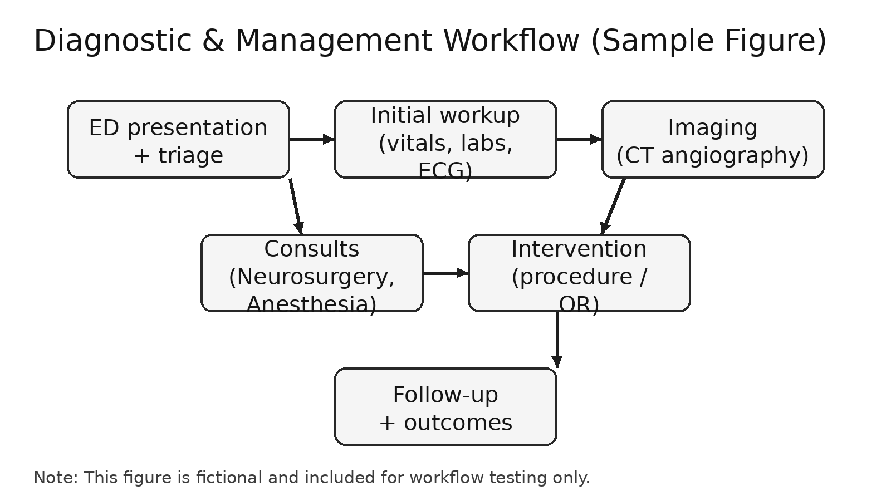
Figure 2. Diagnostic and management workflow (fictional example).

Informed Consent and Ethics
Written informed consent for publication was obtained from the patient (fictional statement for workflow testing). All potentially identifying details have been removed or anonymized.

Disclosures

Conflicts of Interest:
None declared.

Funding:
None.

Data Availability:
Not applicable.

Author Contributions:
All authors contributed to drafting, review, and final approval of the manuscript.

References
- Riley DS, Barber MS, Kienle GS, et al. CARE guidelines for case reports: explanation and elaboration. J Clin Epidemiol. 2017;89:218-235.
- Greenhalgh T. How to read a paper: the basics of evidence-based medicine. 6th ed. Wiley-Blackwell; 2019.
- International Committee of Medical Journal Editors. Recommendations for the conduct, reporting, editing, and publication of scholarly work in medical journals. Updated 2024.

